**Ideation Phase**

**Brainstorm & Idea Prioritization Template**

|  |  |
| --- | --- |
| Date |  |
| Team ID | PNT2025TMID09657 |
| Project Name | Rentease-HOUSE RENT APP USING MERN |
| Maximum Marks | 4 Marks |

**Brainstorm & Idea Prioritization Template:**

In the early stages of building **Rentease** a **House Rent Management Web Application**, it is essential to engage in structured brainstorming to generate diverse ideas, followed by an effective prioritization strategy to ensure we focus on high-impact, feasible features first.

**Step-1: Team Gathering, Collaboration and Select the Problem Statement**

**Team Gathering:** 4 group members divided task for project.

**Team Collaboration Tools:**

Communication Platform: WhatsApp / telegram

Code Collaboration Tool: GitHub (Repositories)

|  |  |
| --- | --- |
| Meeting Frequency : | Twice a week (online via Google Meet) |
|  |

|  |  |
| --- | --- |
|  |  |

**Problem Statement:**

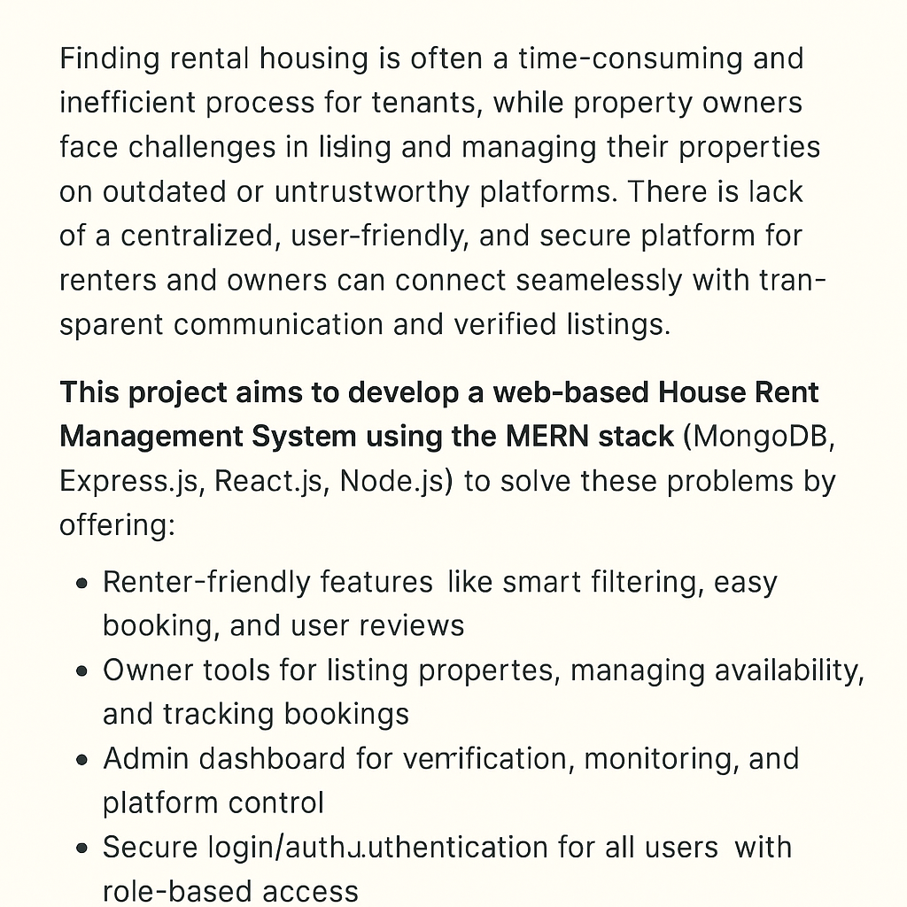

**Step-2: Brainstorm, Idea Listing and Grouping :**

**Idea Listing :**

* Role-based dashboard: Renter / Owner / Admin
* Property search with filters: location, price, type, availability Property detail page with photos, description, map integration

|  |
| --- |
| * Booking system with date selection and confirmation |
| * Owner & Renter profile management * Property suggestion based on user preferences. |

|  |
| --- |
|  |

**Grouping :**

|  |  |
| --- | --- |
| Project Name: | RentEase |

|  |  |
| --- | --- |
| Total Members | : 4 |

|  |  |
| --- | --- |
| Member Roles | - Member 1 – Frontend Developer (React) - Member 2 – Backend Developer (Node.js + Express) - Member 3 – Database & Deployment (MongoDB, Atlas, GitHub) - Member 4 – UI/UX Design & Documentation. |

**Step-3: Idea Prioritization :**

